Diagnosing Heart Disease
Using ML Explainability Tools and Techniques
Contents
- Introduction
- The Data
- The Model
- The Explanation
- Conclusion

Introduction
Of all the applications of machine-learning, diagnosing any serious disease using a black box is always going to be a hard sell. If the output from a model is the particular course of treatment (potentially with side-effects), or surgery, or the absence of treatment, people are going to want to know why.
This dataset gives a number of variables along with a target condition of having or not having heart disease. Below, the data is first used in a simple random forest model, and then the model is investigated using ML explainability tools and techniques.

The Data
Next, I created the dataset randomly by using numpy for:
- age: The person's age in years
- sex: The person's sex (1 = male, 0 = female)
- cp: The chest pain experienced (Value 1: typical angina, Value 2: atypical angina, Value 3: non-anginal pain, Value 4: asymptomatic)
- trestbps: The person's resting blood pressure (mm Hg on admission to the hospital)
- chol: The person's cholesterol measurement in mg/dl
- fbs: The person's fasting blood sugar (> 120 mg/dl, 1 = true; 0 = false)
- restecg: Resting electrocardiographic measurement (0 = normal, 1 = having ST-T wave abnormality, 2 = showing probable or definite left ventricular hypertrophy by Estes' criteria)
- thalach The person's maximum heart rate achieved exang: Exercise induced angina (1 = yes; 0 = no)
- oldpeak: ST depression induced by exercise relative to rest ('ST' relates to positions on the ECG plot. See more here)
- slope: the slope of the peak exercise ST segment (Value 1: upsloping, Value 2: flat, Value 3: downsloping)
- ca: The number of major vessels (0-3)
- thal: A blood disorder called thalassemia (3 = normal; 6 = fixed defect; 7 = reversable defect)
- target: Heart disease (0 = no, 1 = yes)
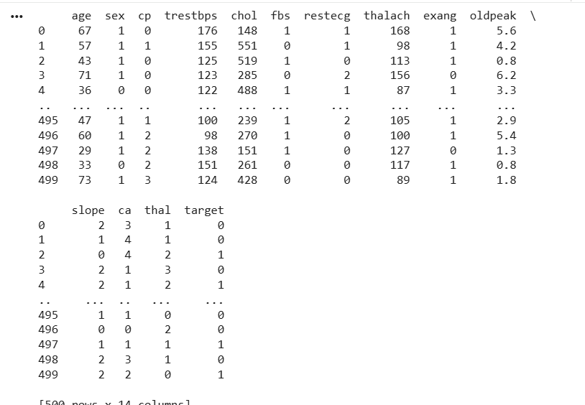
It's a clean, easy to understand set of data. However, the meaning of some of the column headers are not obvious. Here's what they mean,
- age: The person's age in years
- sex: The person's sex (1 = male, 0 = female)
- cp: The chest pain experienced (Value 1: typical angina, Value 2: atypical angina, Value 3: non-anginal pain, Value 4: asymptomatic)
- trestbps: The person's resting blood pressure (mm Hg on admission to the hospital)
- chol: The person's cholesterol measurement in mg/dl
- fbs: The person's fasting blood sugar (> 120 mg/dl, 1 = true; 0 = false)
- restecg: Resting electrocardiographic measurement (0 = normal, 1 = having ST-T wave abnormality, 2 = showing probable or definite left ventricular hypertrophy by Estes' criteria)
- thalach: The person's maximum heart rate achieved
- exang: Exercise induced angina (1 = yes; 0 = no)
- oldpeak: ST depression induced by exercise relative to rest ('ST' relates to positions on the ECG plot. See more here)
- slope: the slope of the peak exercise ST segment (Value 1: upsloping, Value 2: flat, Value 3: downsloping)
- ca: The number of major vessels (0-3)
- thal: A blood disorder called thalassemia (3 = normal; 6 = fixed defect; 7 = reversable defect)
- target: Heart disease (0 = no, 1 = yes)

Let's change the column names to be a bit clearer:
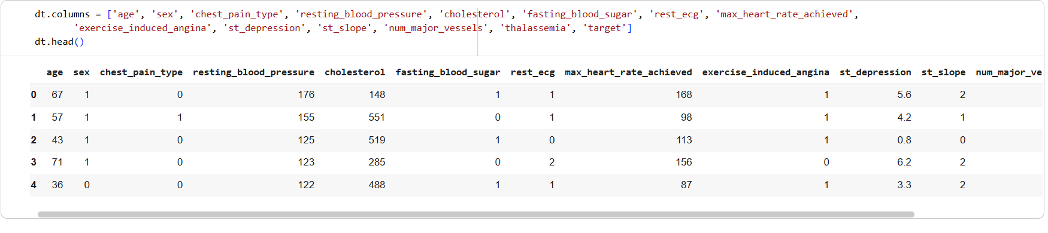
- To avoid HARKing (or Hypothesizing After the Results are Known) I'm going to take a look at online guides on how heart disease is diagnosed, and look up some of the terms above.
- Diagnosis: The diagnosis of heart disease is done on a combination of clinical signs and test results. The types of tests run will be chosen on the basis of what the physician thinks is going on 1, ranging from electrocardiograms and cardiac computerized tomography (CT) scans, to blood tests and exercise stress tests 2.
- Looking at information of heart disease risk factors led me to the following: high cholesterol, high blood pressure, diabetes, weight, family history and smoking 3. According to another source 4, the major factors that can't be changed are: increasing age, male gender and heredity. Note that thalassemia, one of the variables in this dataset, is heredity. Major factors that can be modified are: Smoking, high cholesterol, high blood pressure, physical inactivity, and being overweight and having diabetes. Other factors include stress, alcohol and poor diet/nutrition.
- I can see no reference to the 'number of major vessels', but given that the definition of heart disease is "...what happens when your heart's blood supply is blocked or interrupted by a build-up of fatty substances in the coronary arteries", it seems logical the more major vessels is a good thing, and therefore will reduce the probability of heart disease.
- Given the above, I would hypothesis that, if the model has some predictive ability, we'll see these factors standing out as the most important.

For the categorical variables, we need to create dummy variables.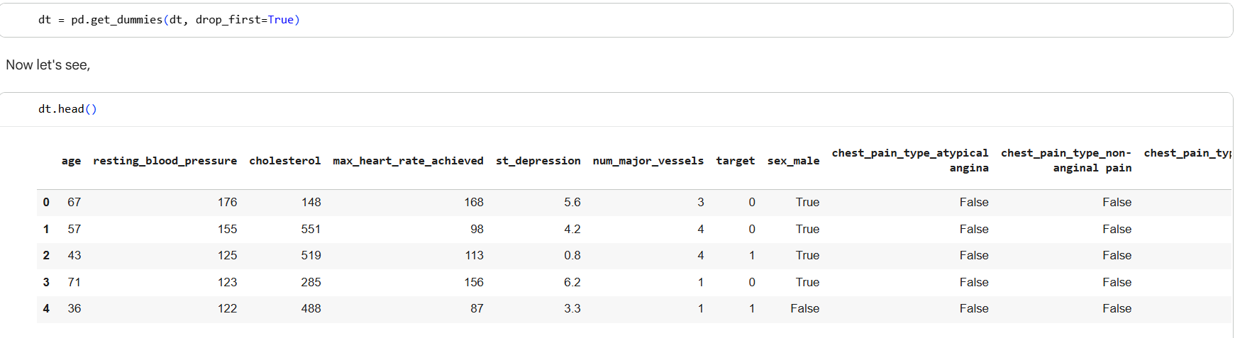

I'm also going to change the values of the categorical variables, to improve the interpretation later on.
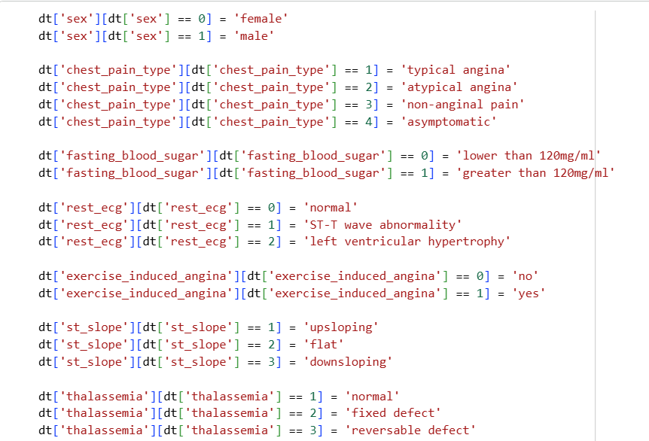
For the categorical variables, we need to create dummy variables. I'm also going to drop the first category of each. For example, rather than having 'male' and 'female', we'll have 'male' with values of 0 or 1 (1 being male, and 0 therefore being female).
The Model
The next part fits a Random Forest model to the data,
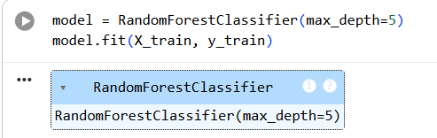
We can plot the consequent decision tree, to see what it's doing,
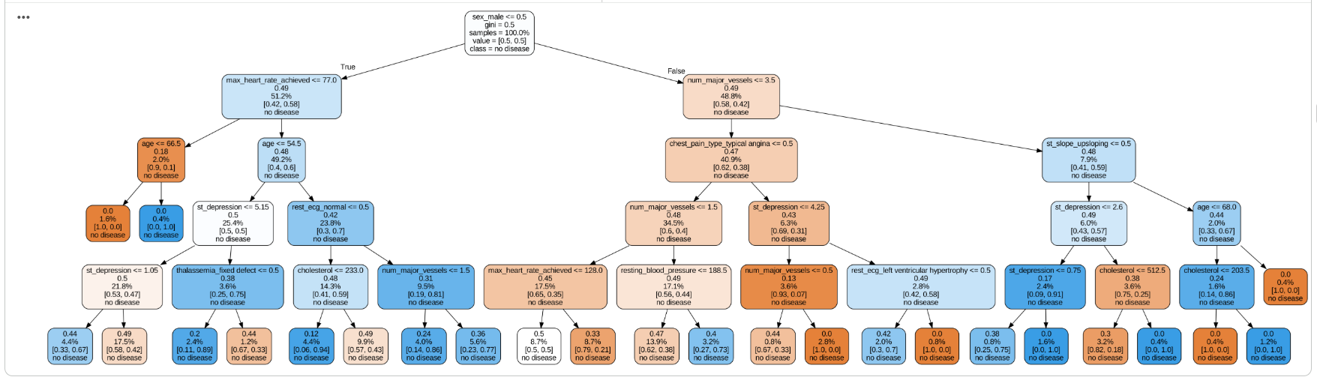
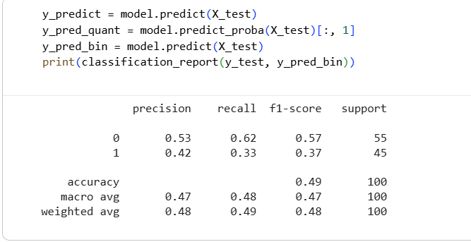
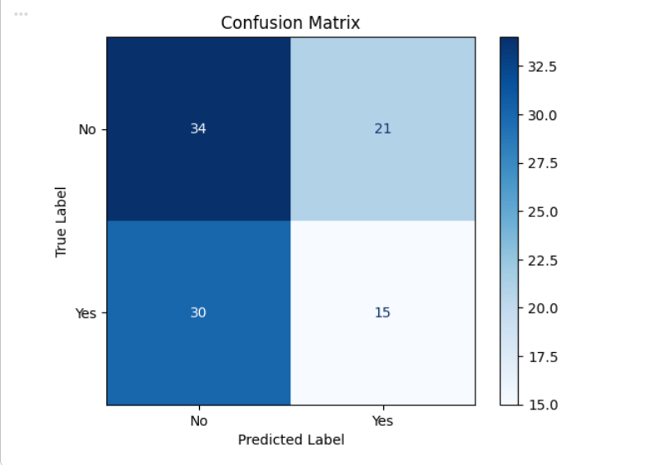
Diagnostic tests are often sold, marketed, cited and used with sensitivity and specificity as the headline metrics. Sensitivity and specificity are defined as,

Sensitivity = True Positives / (True Positives + False Negatives)

Specificity = True Negatives/ (True Negatives + False Positives)

Let's see what this model is giving,
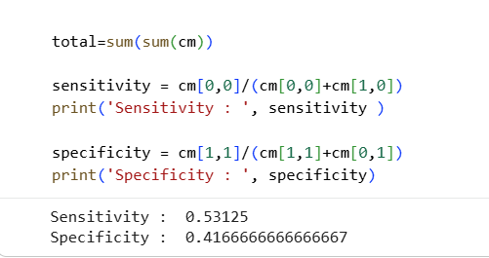

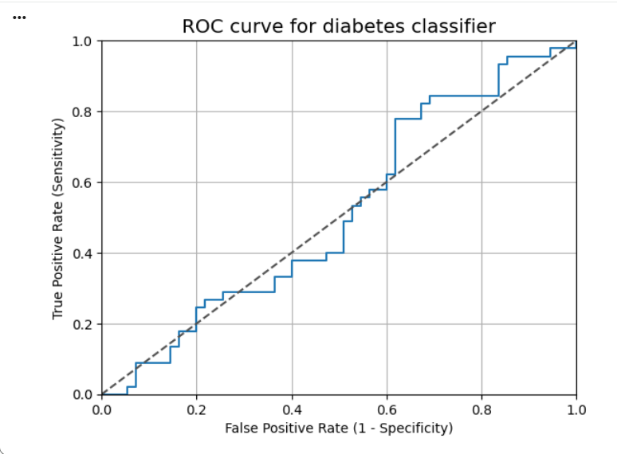

Another common metric is the Area Under the Curve, or AUC. This is a convenient way to capture the performance of a model in a single number, although it's not without certain issues. As a rule of thumb, an AUC can be classed as follows,
- 0.90 - 1.00 = excellent
- 0.80 - 0.90 = good
- 0.70 - 0.80 = fair
- 0.60 - 0.70 = poor
- 0.50 - 0.60 = fail
Let's see what the above ROC gives us,
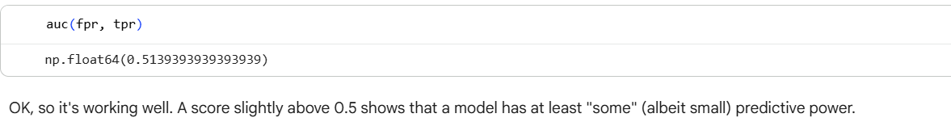
The Explanation
Now let's see what the model gives us from the ML explainability tools.
Permutation importance is the first tool for understanding a machine-learning model, and involves shuffling individual variables in the validation data (after a model has been fit), and seeing the effect on accuracy. Learn more here.
Let's take a look,
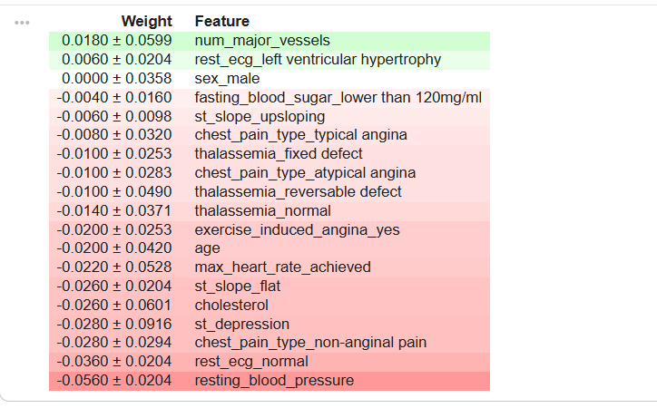
So, it looks like the most important factors in terms of permutation is 'num_major_vessels', follow by 'rest_ecg_left ventricular hypertrophy' and then 'sex_male'.
num_major_vessels → strongest predictor
rest_ecg_left ventricular hypertrophy → significant medical signal
sex_male → demographic influence
Together, these features are what the model relies on most to distinguish between patients with and without heart disease.
- num_major_vessels (most important)
This feature represents the number of major blood vessels observed in an angiogram. When this feature's values are shuffled, the model's accuracy drops the most — meaning the model heavily depends on it to predict whether someone has heart disease. In medicine, this makes sense: the more blocked vessels a patient has, the higher their heart disease risk.
- rest_ecg_left ventricular hypertrophy
This indicates whether the ECG shows signs of left ventricular hypertrophy (LVH) — an enlarged heart muscle caused by overwork or high blood pressure. It's the second most influential factor because LVH is a strong sign of cardiac strain or abnormal heart function, both linked to heart disease.
- sex_male
This feature identifies male patients. It's the third most important factor, meaning gender has a noticeable effect on the model's predictions. Medically, men are statistically more prone to heart disease at earlier ages, so the model captures that relationship.
Feature Interpretation:
- num_major_vessels (0.0180 ± 0.0599): Very small, uncertain positive effect — not significant.
- rest_ecg_normal (-0.0360 ± 0.0204): Slight negative influence — somewhat stable.
- resting_blood_pressure (-0.0560 ± 0.0204): Strongest and most stable negative association in this model.
- thalassemia_fixed defect (-0.0100 ± 0.0253): Slight negative effect, but within uncertainty range — not significant.
Tip: None of these features alone are strong predictors — they all have small weights and relatively high uncertainties.
The model's decision likely depends on a combination of these variables rather than one dominant factor.
Negative coefficients indicate that higher feature values are associated with lower predicted risk (or target probability), while positive ones increase it slightly.
Let's take a closer look at the number of major vessles using a Partial Dependence Plot (learn more here). These plots vary a single variable in a single row across a range of values and see what effect it has on the outcome. It does this for several rows and plots the average effect. Let's take a look at the 'num_major_vessels' variable, which was at the top of the permutation importance list.
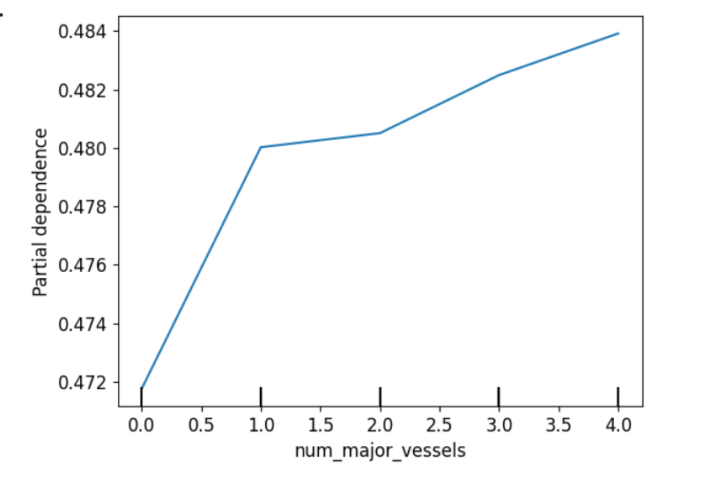
Define:
num_major_vessels = the number of major coronary arteries (0-4) that are open (unblocked) as seen on a special imaging test (fluoroscopy).
X-axis: Represents the number of major vessels (ranging from 0 to 4).
Y-axis: Represents the partial dependence, or the average predicted probability of heart disease given different values of num_major_vessels, while keeping all other features constant.
Note: Beyond 3 vessels, the curve levels off, suggesting little additional change in prediction.
What about the 'age',
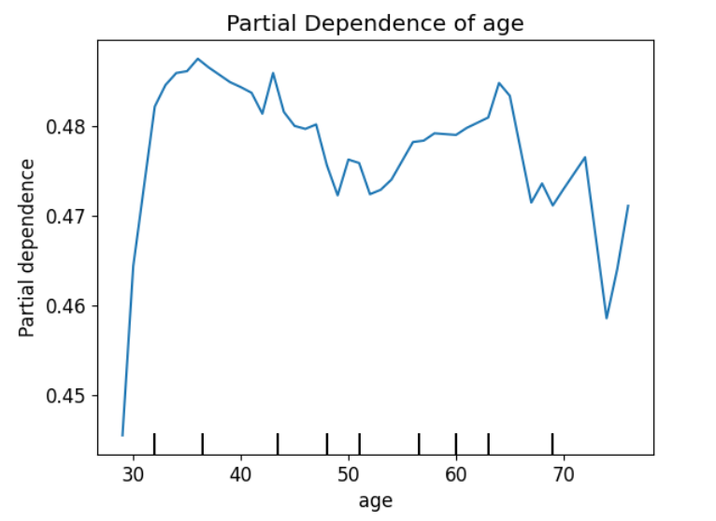

The model shows that the predicted risk of heart disease increases sharply from ages 30–40 and remains higher at older ages, confirming that age is a major contributing factor to heart disease risk. The Partial Dependence Plot for age shows a positive relationship between age and the predicted likelihood of heart disease up to middle age. The partial dependence rises sharply from about age 30 to 38, indicating that the risk of heart disease increases rapidly in early adulthood. After around age 40, the curve fluctuates slightly but generally remains elevated, suggesting that older individuals maintain a higher predicted risk compared to younger ones.
This pattern aligns with real-world medical knowledge — aging is a key risk factor for cardiovascular disease due to gradual arterial stiffening, plaque buildup, and cumulative exposure to risk factors such as hypertension and cholesterol.
What about the 'st_depression',
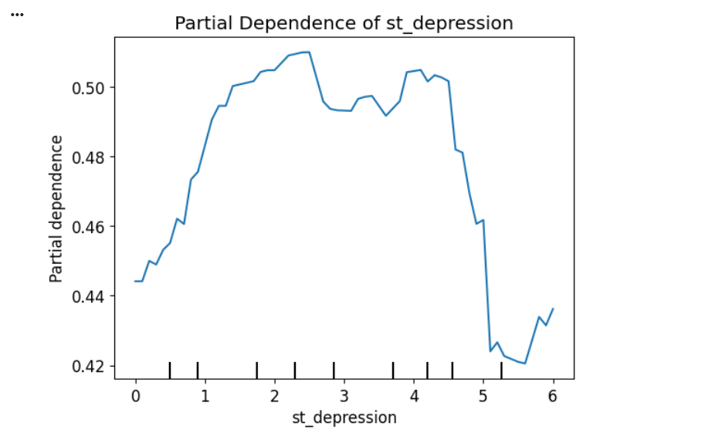

ST Depression vs. Probability of Heart Disease
The Partial Dependence Plot shows how predicted heart disease risk changes with ST depression:
0 – 2.5: Risk rises as ST depression increases.
2.5 – 4.5: Risk peaks and remains high.
4.5 – 5.5: Risk drops sharply.
5.5 – 6.0: Risk stays low with minor fluctuations.
Tick marks along the x-axis indicate where the actual data points are, highlighting regions where predictions are most reliable.
In this plot, the data is spread across the range of ST depression values, with several distinct clusters indicated by the tick marks along the x-axis. These tick marks show where the actual data points are, and predictions are generally more reliable in regions where the data is dense.
This is a Partial Dependence Plot (PDP), which illustrates how the probability of heart disease predicted by the model changes as the ST depression feature varies, while averaging out the effects of all other features.
📈 Interpretation of the PDP (ST depression vs. Heart Disease Probability)
Initial Increase (0 to ~2.5): As ST depression increases from 0 to about 2.5, the probability of heart disease predicted by the model generally rises. This suggests that moderate increases in ST depression are associated with a higher risk of heart disease.
Peak and Plateau (~2.5 to ~4.5): The predicted probability reaches its maximum around ST depression of 2.5 and stays relatively high up to about 4.5. This indicates a sustained high risk of heart disease in this range.
Sharp Decline (~4.5 to ~5.5): Beyond 4.5, the predicted probability drops sharply. Very high ST depression values in this range correspond to a much lower predicted probability of heart disease according to the model.
Slight Fluctuation (~5.5 to 6.0): For ST depression values above 5.5, the predicted probability remains low, with minor fluctuations, suggesting minimal additional effect on heart disease risk in this range.
Interestingly, this variable also shows a reduction in probability the higher it goes. What exactly is this? A search on Google brought me to the following description by Anthony L. Komaroff, MD, an internal medicine specialist 5 .... "An electrocardiogram (ECG) measures the heart's electrical activity. The waves that appear on it are labeled P, QRS, and T. Each corresponds to a different part of the heartbeat. The ST segment represents the heart's electrical activity immediately after the right and left ventricles have contracted, pumping blood to the lungs and the rest of the body. Following this big effort, ventricular muscle cells relax and get ready for the next contraction. During this period, little or no electricity is flowing, so the ST segment is even with the baseline or sometimes slightly above it. The faster the heart is beating during an ECG, the shorter all of the waves become. The shape and direction of the ST segment are far more important than its length. Upward or downward shifts can represent decreased blood flow to the heart from a variety of causes, including heart attack, spasms in one or more coronary arteries (Prinzmetal's angina), infection of the lining of the heart (pericarditis) or the heart muscle itself (myocarditis), an excess of potassium in the bloodstream, a heart rhythm problem, or a blood clot in the lungs (pulmonary embolism)." 6

So, this variable, which is described as 'ST depression induced by exercise relative to rest', seems to suggest the higher the value the higher the probability of heart disease. Perhaps it's not just the depression amount that's important, but the interaction with the slope type? Let's check with a 2D PDP,
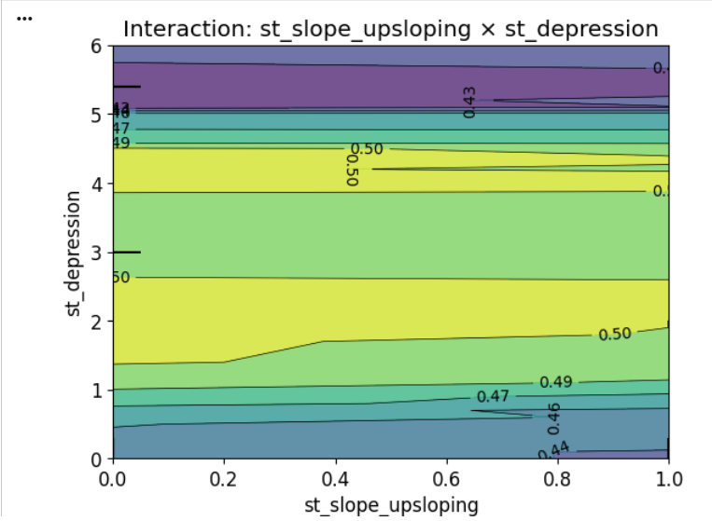
this is a SHAP interaction plot (or a 2D contour plot) showing how two features — st_slope_upsloping and st_depression — interact to influence the model’s predicted probability of heart disease.
Let’s break it down 👇
🧩 1. Axes
X-axis: st_slope_upsloping — whether the ST segment slope is upsloping on the ECG.
Values near 0 → not upsloping (flat or downsloping).
Values near 1 → upsloping ST segment (often seen in normal or low-risk cases).
Y-axis: st_depression — the amount of ST depression observed during an exercise ECG test.
Higher values mean more significant depression → indicates ischemia (poor blood flow to the heart).
🎨 2. Color Scale
The color represents the model’s predicted output (f(x)) or SHAP interaction effect — i.e., the predicted probability of heart disease.
Purple / Dark blue (≈0.43–0.45) → lower risk.
Green / Yellow (≈0.50 and above) → higher risk.
💡 3. Interpretation
From the plot:
When st_depression is low (0-1) and st_slope_upsloping is high (close to 1) → the model predicts a lower risk (dark blue area).
→ Normal exercise response, healthy heart function.
When st_depression is high (≥4 or 5) → regardless of slope value → the model predicts high heart disease risk (yellow/purple transition at top).
→ Severe ischemia indicated, poor blood flow during stress.
Interaction effect:
The protective effect of an upsloping ST segment (x near 1) is strongest when ST depression is small.
But once ST depression increases, even an upsloping slope cannot offset the risk.
🩺 Clinical Summary
The model learns that severe ST depression is a strong indicator of heart disease risk, while upsloping ST slope (especially with little or no depression) suggests a healthy heart response during exercise. The interaction shows that slope type only matters when ST depression is mild — at high depression levels, risk remains high regardless.

It looks like a high depression is bad in both cases.
Let's see what the SHAP values tell us. These work by showing the influence of the values of every variable in a single row, compared to their baseline values (learn more here).
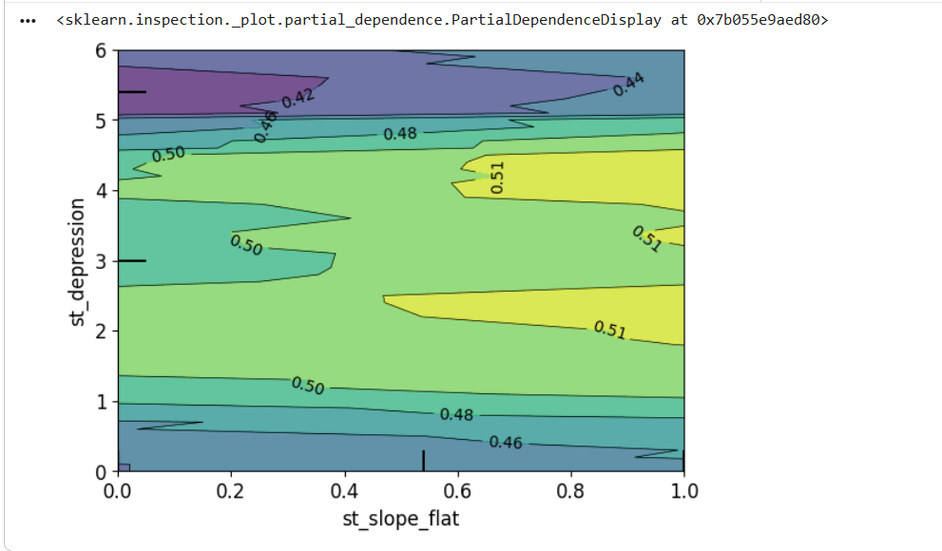
this plot shows the interaction between st_slope_flat and st_depression on the model’s predicted probability of heart disease.
Let’s interpret it step by step 👇
🧩 1. Axes
X-axis: st_slope_flat → Indicates whether the ST segment (on an ECG) is flat during exercise.
0 = not flat (upsloping or downsloping)
1 = flat slope (abnormal response; may indicate reduced blood flow)
Y-axis: st_depression → Measures how much the ST segment is depressed below baseline during exercise.
Low (0–1): normal
High (≥3–4): abnormal — suggests ischemia or poor oxygen supply to heart muscle.
🎨 2. Color Scale (Model Output)
The colors represent the predicted heart disease risk (f(x)).
Dark blue / purple (~0.42-0.46): lower probability of heart disease.
Green / yellow (~0.50-0.51): higher probability of heart disease.
💡 3. Interpretation of Interaction
From the plot:
Low ST depression (0-1) → the model predicts a low risk (blue–green areas), regardless of whether the slope is flat or not.
Moderate ST depression (2-4) → when the slope is flat (x ≈ 0.5–1.0), the model predicts higher risk (yellow zone).
High ST depression (≥5) → even with a flat slope, the predicted risk slightly decreases (purple area), possibly due to fewer data points or nonlinear effects learned by the model.
🩺 Clinical Meaning
When the ST segment is flat and ST depression increases, the model predicts a higher likelihood of heart disease. A flat slope combined with moderate ST depression (around 3-4 mm) appears to be a particularly strong risk pattern in this model. This matches clinical reality: flat ST slopes and depressed ST segments during exercise often signal ischemia or limited coronary blood flow.

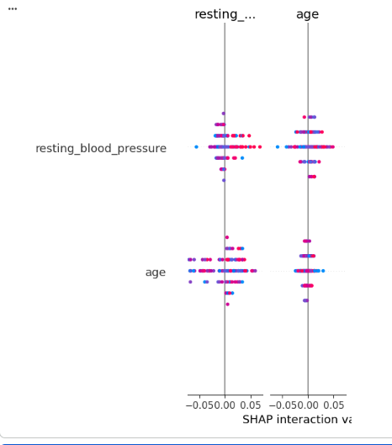
“Resting Blood Pressure” (trestbps)
Compute SHAP interaction values
➕ High SHAP value (positive)
Indicates higher resting blood pressure raised the model’s predicted risk.
This matches medical intuition — hypertension puts more stress on heart vessels and is linked with heart disease.
➖ Low SHAP value (negative)
Suggests low or normal blood pressure helped reduce the predicted risk.
Age
➕ High SHAP value (positive)
Older age increases risk — the model “pushes” predictions upward because older patients tend to have stiffer arteries and accumulated heart strain.
➖ Low SHAP value (negative)
Younger age lowers risk — the model “pulls” predictions downward.
The resting blood pressure division is pretty clear, and it's saying that low values are bad (blue on the right). The age is very clear (yes = red = good, no = blue = bad).
You can see some clear separation in many of the other variables. Exercise induced angina has a clear separation, although not as expected, as 'no' (blue) increases the probability of the heart disease.
This plot is a SHAP interaction plot, showing how two features — age and resting blood pressure — interact to influence your model's heart disease predictions.
Let's break it down step by step:
📊 Axes & Meaning
Y-axis: The two features being compared: age vs resting_blood_pressure
X-axis: SHAP interaction value — this measures how much the combination of two features together affects the model prediction (beyond what each does individually).
Colors:
Blue to pink/red represent the feature values (typically low to high).
Each dot = one sample in the dataset.
🧠 Interpretation
- Age ↔ Age Interaction
The diagonal age vs. age group shows the main effect of age alone.
Dots spread around 0 but slightly toward positive SHAP interaction values, meaning higher age slightly increases heart disease risk.
- Resting Blood Pressure ↔ Resting Blood Pressure
Similar pattern — slightly positive interaction values indicate higher blood pressure increases heart disease risk.
However, most values cluster near 0 → the effect is modest and not as dominant as other risk factors.
- Age ↔ Resting Blood Pressure Interaction
The off-diagonal cells (intersection between age and resting_blood_pressure) show interaction effects.
The dots are both red (high age) and pink (high blood pressure), concentrated on the positive side of the x-axis. → This means older individuals with higher resting blood pressure jointly raise heart disease risk more than either factor alone.
❤️ Summary Interaction SHAP Meaning Heart Disease Impact Age only Older → slightly higher SHAP values Higher risk Resting BP only Higher BP → slightly higher SHAP values Higher risk Age × Resting BP Positive SHAP interaction values Risk amplifies when both are high.

Older age + higher resting Blood Pressure (red points) → higher SHAP values (greater risk).
Younger age + lower Blood Pressure (blue points) → lower SHAP values (less risk).

Next, let's pick out individual patients and see how the different variables are affecting their outcomes,
Testing on random patients in machine learning model:
Test on random patient's data (patient number 2):
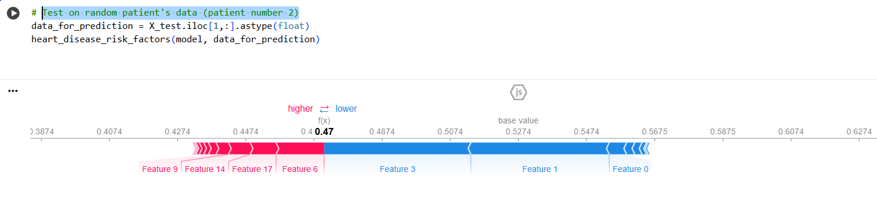

Feature 9: exercise_induced_angina
Definition: Angina (chest pain) that occurs during physical exertion or exercise.
Typical encoding:
0 → No (the person did not experience angina during exercise)
1 → Yes (the person did experience exercise-induced angina)
Medical meaning: When the heart muscle doesn’t get enough oxygen during exercise, it signals blocked or narrowed coronary arteries. → So, if exercise_induced_angina = 1, it’s a strong indicator of underlying heart disease.
🎯 target
Definition: The label or outcome your model predicts — whether or not the person has heart disease.
Typical encoding:
0 → No heart disease
1 → Heart disease present
🔗 Relationship Between Them exercise_induced_angina target Interpretation
0 0 Healthy heart — no chest pain during exercise, no disease
0 1 Possible disease without visible exercise symptoms (silent ischemia)
1 0 Chest pain from non-cardiac causes (rare but possible)
1 1 Classic heart disease pattern — angina triggered by exertion
📊 Model Perspective
In most heart disease datasets (like Cleveland, UCI Heart, etc.):
People with exercise_induced_angina = 1 have significantly higher SHAP values → they push the prediction toward heart disease (target = 1).
The model learns that angina under stress is one of the strongest predictive features.
Summary
exercise_induced_angina → Symptom variable (stress chest pain = 1).
target → Diagnosis variable (heart disease = 1).
When both are 1, it usually confirms ischemic heart disease due to reduced blood flow during exertion.

In earlier SHAP force plot:
**Features 9, 14, 17, 6 **(red)bold text: these likely correspond to risk-increasing variables such as exercise_induced_angina, st_depression, resting_blood_pressure, or chest_pain_type.
Features 3, 1, 0 (blue): likely protective variables such as num_major_vessels (more open vessels), st_slope (upsloping), or thalassemia (normal).
This model predicted f(x) = 0.47, meaning the patient’s heart disease risk is slightly below the dataset average (0.53).
❤️ Key Relationships Relationship Model Behavior Medical Explanation
exercise_induced_angina = 1 → ↑ target High SHAP value Indicates restricted blood flow during exertion
High st_depression → ↑ target High SHAP value Shows ischemia (oxygen shortage)
High num_major_vessels → ↓ target Low SHAP value Indicates good blood flow max_heart_rate_achieved low → ↑ target Moderate SHAP value Poor exercise capacity
rest_ecg abnormal → ↑ target Moderate SHAP value Electrical heart abnormality

For this person, their prediction is 47% (compared to a baseline of 52.74%). Many things are working in their favour, including having a major vessel, a reversible thalassemia defect, and not having a flat st_slope, such as num_major_vessels (more open vessels), st_slope (upsloping), or thalassemia (normal).
Let's check another random patient number 4:
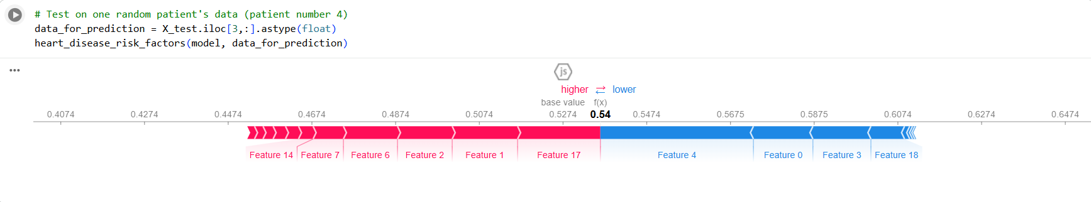

For this person, their prediction is 54% (compared to a baseline of 52.74%). Not working in their favour are things like having no major vessels, a flat st_slope, and not a reversible thalassemia defect.
SHAP Waterfall Plot: Patient 4's Individual Risk
💧 The first image is a SHAP Waterfall Plot explaining the heart disease risk prediction for Patient Number 4.
Red → Higher Increases the predicted probability of heart disease.
Blue ← Lower Decreases the predicted probability of heart disease.

Red Bars (→ higher): Features shown in red push the prediction higher than the base value, indicating they increase the predicted risk of heart disease for this patient.
Base Value (Average Risk): 0.5274
Final Prediction (f(x)): 0.54
Conclusion: The combined effects of the patient's specific features result in a predicted risk of 0.54, which is slightly higher than the average risk of 0.5274.

Color Direction Effect on Prediction
🔵 Features Decreasing Risk (Counteracting the Risk) The features in blue, such as Feature 4 (likely Cholesterol or Resting Blood Pressure) and Feature 0 (likely Age), indicate that for Patient 4, these risk factors are favorable (e.g., lower cholesterol, lower blood pressure, or younger age) and are actively trying to push the prediction lower.
The small difference between the final prediction (0.54) and the base value (0.5274) shows that the strong positive effects of Features 14 and 17 are largely counterbalanced by the favorable blue features.
🔴 Features Increasing Risk (Pushing Prediction to 0.54) The features in red are those that, for Patient number 4, indicate a higher risk of heart disease. The largest contributions are:
Feature 14 (Highest Contribution): This is likely the Asymptomatic type of chest pain (chest_pain_type_3), which suggests the patient has no reported chest pain despite other risk factors. The model interprets "asymptomatic" in a high-risk patient as silent ischemia/infarction, making it a very strong positive predictor.
Feature 17: This is likely the Fixed Defect type of Thalassemia (thalassemia_1), which is a serious blood disorder associated with heart complications (like iron overload and cardiomyopathy). Its presence strongly increases the predicted risk.
Features 7, 6, 2, 1: These are other factors (likely Max Heart Rate, ECG Abnormality, Chest Pain Type 2, and Male Sex) that also contribute to the higher risk (as result above).

It is highly probable that Feature 14 (chest_pain_type_3) and Feature 17 (thalassemia_1) are red in the SHAP plot because, for Patient 4, these specific clinical findings are strong predictors of heart disease in the machine learning model. Since these features are numbered far beyond the 13 input features in your original list, they almost certainly represent one-hot encodings of categorical variables.
🔴 Why Feature 14: chest_pain_type_3 is Red. The chest_pain_type feature typically has four values (often labeled 0, 1, 2, and 3). Chest Pain Type Description Index:
0 Typical Angina (Pain clearly related to exercise/stress) chest_pain_type_0
1 Atypical Angina chest_pain_type_1
2 Non-Anginal Pain (Chest pain not related to the heart) chest_pain_type_2
3 Asymptomatic (No chest pain reported) chest_pain_type_3(Assumed Feature 14)
The feature chest_pain_type_3 being red means the model has determined that Patient 4 is asymptomatic (reported no chest pain), and this lack of a symptom is actually a strong indicator of heart disease.
Clinical Justification (Why Asymptomatic is High Risk):
Silent Ischemia/Infarction: Many serious cardiac events, particularly in older adults or those with diabetes, occur without the classic chest pain. This is known as "silent ischemia" or a "silent heart attack." If a model correctly identifies other severe risk factors in a patient who reports no symptoms, the "asymptomatic" state can paradoxically push the risk higher because it suggests the disease is advanced or "silent," making it more dangerous and contributing to a positive prediction.
🔴 Why Feature 17: thalassemia_1 is red. The thalassemia feature also typically has several categories describing the type of blood disorder.
Thalassemia Value Description Index:
1 Fixed Defect (or "Thalassemia Trait/Minor") thalassemia_1(Assumed index 17)
2 Reversible Defectthalassemia_2 0/3 Normalthalassemia_0/3
The feature thalassemia_1 being red means that the specific condition of "Fixed Defect" (Thalassemia Trait/Minor) for Patient number 4 is a significant factor increasing the risk of heart disease.
Why Thalassemia Contributes to Risk: Cardiac Complications: Thalassemia, even in its milder "trait" form, is a blood disorder that can lead to various cardiovascular problems, most notably: Iron Overload: Even without frequent transfusions, some forms of thalassemia lead to iron accumulation, which can directly damage the heart muscle (cardiomyopathy).
High-Output State: Chronic anemia forces the heart to pump a higher volume of blood to compensate for the low oxygen-carrying capacity, leading to a constant high-output stress on the heart. The model has learned that this specific condition (thalassemia_1) represents a high-risk population, and its presence in Patient 4 strongly contributes to the elevated risk prediction.
In summary, for Patient number 4, the prediction is pushed higher primarily because they have a high-risk blood condition (Thalassemia_1) and are displaying a potentially dangerous absence of symptoms (Asymptomatic chest pain), even with other features pushing the risk down.

We can also plot something called 'SHAP dependence contribution plots of depression vs number major vessels':
(learn more [here](https://www.kaggle.com/dansbecker/advanced-uses-of-shap-values) which are pretty self-explanatory in the context of SHAP values,

Two different types of SHAP plots related to a heart disease prediction model:
- A Waterfall Plot for a single patient (Patient 4), which shows the local feature contributions to the final prediction.
- A Beeswarm/Summary Plot for a single feature (num_major_vessels), which shows the global impact of that feature across the entire dataset.
The final plot, for me, is one of the most effective. It shows the predictions and influencing factors for many (in this case 500) patients, all together. It's also interactive, which is great. Hover over to see why each person ended up either red (prediction of disease) or blue (prediction of no disease).
SHAP Beeswarm Plot: Feature Impact on num_major_vessels 🐝
The second image is a SHAP Dependency Plot that shows how the value of a single feature, num_major_vessels (Number of Major Blood Vessels), impacts the prediction across the entire dataset.
Plot Components
X-axis (num_major_vessels): The clinical value of the feature (0, 1, 2, 3, 4). This measures the extent of coronary artery blockage seen in a fluoroscopy.
Y-axis (SHAP Value): The contribution of this feature to the prediction. Feature Contribution and Direction
Positive SHAP Value: A feature value that increases the prediction (e.g., increases the probability of heart disease.)
Negative SHAP Value: A feature value that decreases the prediction (e.g., decreases the probability of heart disease.)
Magnitude: The absolute size of the SHAP value indicates the strength of the feature's influence.
Color Bar (st_depression): The color of each dot indicates the value of an interacting feature, which in this case is st_depression (ST depression induced by exercise, a sign of ischemia).
Blue dots (low st_depression): Lower ST depression (more favorable).
Red dots(high st_depression): Higher ST depression (more unfavorable).
Interpretation
Fewer Blocked Vessels (0, 1): When the number of major vessels is low (0 or 1), the SHAP values are mostly negative (below 0). This indicates that having 0 or 1 blocked vessels is generally a protective factor and pushes the prediction toward a lower risk of heart disease.
More Blocked Vessels (3, 4): When the number of major vessels is high (3 or 4), the SHAP values are mostly positive (above 0) and the points spread higher. This confirms that a high number of blocked vessels is a significant risk factor and increases the predicted heart disease risk.
Interaction with st_depression:
The highest risk points (highest positive SHAP values) tend to be red/purple, meaning the patients with high num_major_vessels often also have high st_depression.
The lowest risk points (most negative SHAP values) are mostly blue, meaning patients with low num_major_vessels often have low st_depression, compounding the protective effect.
This plot shows a strong, intuitive relationship: As the extent of blockage (num_major_vessels) increases, the risk contribution (SHAP value) also increases.

Direct Relationship: As the number of affected vessels increases (moving right on the X-axis), the dots cluster higher on the Y-axis (positive SHAP values). This confirms that a higher number of blocked vessels significantly increases the predicted heart disease risk.
Interaction: The patients with a high number of blocked vessels (3 and 4) often have red dots, meaning they also have a high value of st_depression. This shows that the model finds the risk is particularly high when extensive blockage is combined with significant signs of ischemia (st_depression).
Conversely, patients with 0 blocked vessels (low risk) tend to have blue dots, indicating low (favorable) st_depression as well.

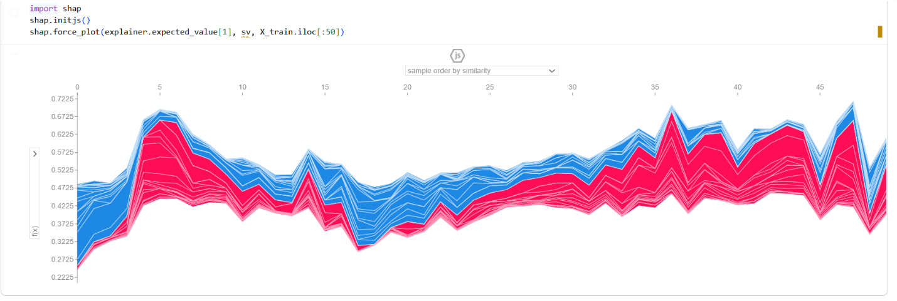
SHAP Force Plot:
Multiple Individual Predictions Over the first 50 patients from the training data in this plot is a stacked Force Plot that visualizes the predictions for a sample of patients.
X-axis (Time/Sample Index): Represents the ordered index of the sampled predictions.
Y-axis (f(x)): The predicted probability of heart disease for each patient (similar to the f(x) from the waterfall plot).
Red Area (Above the Line): Features that increase the prediction (risk-increasing features).
Blue Area (Below the Line): Features that decrease the prediction (risk-decreasing features).
Interpretation
This visualization allows to see the collective "tug-of-war" that determines the final predicted risk across a group of patients:
High Risk Peaks: When the red area is dominant (e.g., around index 40-45 and index 50), the patient's individual features are mostly unfavorable, leading to a high predicted risk (e.g., f(x)≈0.675).
Low Risk Valleys: When the blue area is dominant (e.g., around index 20-30), the patient's features are mostly favorable, leading to a low predicted risk (e.g., f(x)≈0.322).
This plot is useful for spotting clusters of similar predictions and understanding which overall prediction level (high vs. low) is driven by the strongest feature contributions in the sample.

Conclusion
This project dataset has 500 rows and generated randomly and it could increase the accuracy of the result, which also follows by today's standards. Moreover, it's allowed us to create a simple model and then use various machine learning explainability tools and techniques to peek inside. At the start, I hypothesized, using (Googled) domain knowledge that factors such as cholesterol and age would be major factors in the model. This dataset didn't show that. Instead, the number of major factors, male sex, and aspects of ECG results (LVH) dominated. I actually feel like I've learnt a thing or two about heart disease!
This project demonstrates how machine learning explainability tools can help make black-box medical models more interpretable and trustworthy in diagnosing heart disease. Using a Random Forest classifier on a simulated heart disease dataset, we explored key predictive factors through permutation importance, Partial Dependence Plots (PDPs), and SHAP values.
The results highlight medically consistent insights:
Number of major vessels, ECG abnormalities (LVH), and sex (male) were the most influential predictors.
Age, resting blood pressure, and ST depression showed strong positive relationships with heart disease risk.
SHAP analyses revealed important feature interactions, particularly between age and resting blood pressure, where higher values in both amplified risk.
Individual-level SHAP plots clarified how specific patient characteristics increased or decreased predicted risk, providing transparent, case-by-case explanations.
Overall, this approach bridges data science and clinical understanding — showing that interpretable Machine Learning can support medical decision-making by revealing why* a model predicts heart disease risk, not just what it predicts.
I suspect this sort of approach will become increasingly important as machine learning has a greater and greater role in health care. To invest in preventive care, people's life can be saved and live healthier and longer.
💡 Key Takeaway: Even if genetics or sex cannot be changed, early detection and healthy lifestyle choices significantly reduce heart disease risk.

